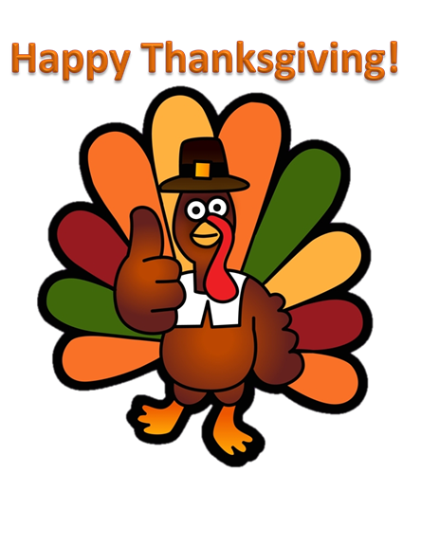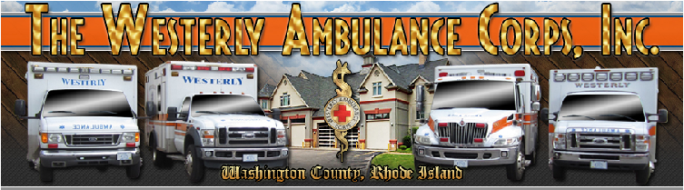

**Pre Order your Thanksgiving Coffee and Donuts to help support The Westerly Ambulance 100th Anniversary**

***One Dozen Glazed Doughnut’s***

**Order from November 14, 2016 through November 19, 2016**

***Payment Due at time of Order (Cash or Check)***

Make checks payable to Westerly Ambulance

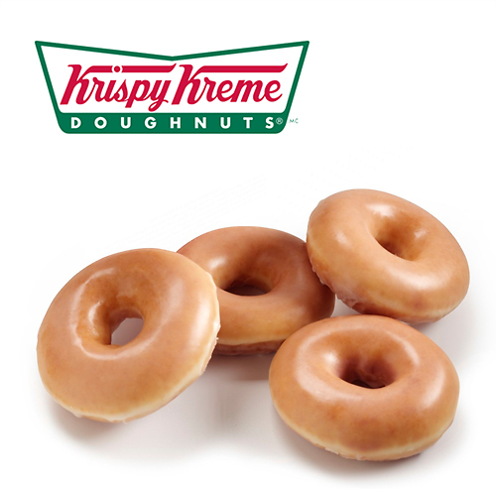

$8.00 Per Dozen

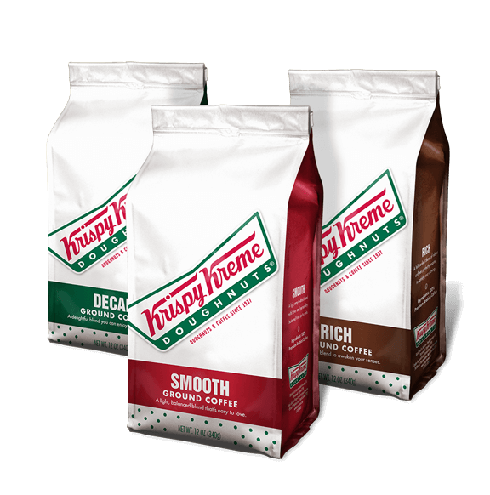 ***Signature Coffee***



**Pick up Orders:**

**Westerly Ambulance Corps**

**30 Chestnut Street**

**Westerly, RI 02891**

**Wednesday November 23, 2016**

**Between 8:00am-4:00pm**

**Contact Person**

**Nick Lassell**

**860-235-6270**

$10.00 Per Bag